"Perioperative outcome study platform"
First generation main observational study
PRELIMINARY DRAFT
SECTION APM (Anesthesia & Perioperative Medicine) –
contact person: Aarne Feldheiser (a.feldheiser@kem-med.com)

Study synopsis of HeCoMo (Association of intraoperative Hemodynamic characteristics with postoperative Complications and Mortality):

This study describes the main observational study to start the perioperative outcome study platform (POP-OUT).

Study title: | Association of intraoperative hemodynamic characteristics with postoperative complications and mortality
Short title: | HeCoMo
Project design: | An international prospective observational study
Background and Rationale: | In perioperative medicine international outcome data of high-risk surgical procedures are scarce or not available to the community. On the other side these data are required to direct future research and identify topics to be addressed to improve clinical care.
Hypothesis: | The hemodynamic characteristics like amounts of intravenously administered fluids, vasopressors, or inotropes are associated with increased postoperative complication rates and severity as well as postoperative mortality.
Outcome (s): | - Postoperative complications according to the Clavien-Dindo classification  - Postoperative mortality (in-house, 3-months, one-year)
Key inclusion criteria: | Patients undergoing elective high-risk surgical procedures, the study team will develop a positive list of procedures to be included.
Number of centers: | It is planned to include as many centers world-wide as possible.
Patients per center: | It is planned to include 20 to 25 patients per center in a predetermined sequence characteristics that every center must determine prior to start recruiting.
Project schedule: | Spring: Study set-up, recruiting potential investigators  Summer 2023: obtaining national ethical approvals  Autumn 2023 to Spring 2024: Inclusion of patients  Summer 2024: Data analysis and writing manuscript
Further Objectives: | The study determines the international variation of hemodynamic care in high-risk surgical procedures. As hemodynamic care includes different therapies the study may offer an insight about the preferences (volume versus vasopressors) and the general usage of inotropes.
Ethical considerations: | The study is planned as observational study and consequently no harm is expected.
Study initiator: | Aarne Feldheiser, M.D., Ph.D., Kliniken Essen-Mitte, Essen, Germany
Authorship: | First author: Aarne Feldheiser, Last author: TBD, co-authors are named according to the “Authorship declaration” document of the PeriOP study platform project.

"Perioperative Outcome Study Platform"
Short name: "POP-OUT"
PRELIMINARY DRAFT
SECTION APM (Anesthesia & Perioperative Medicine) –
contact person: Aarne Feldheiser (a.feldheiser@kem-med.com)

Preamble

The POP-OUT project aims to improve care for our patients and intends to build a community of physicians from all over the world being dedicated to that aim.

The purpose and vision of the POP-OUT study project

In perioperative care outcome data about postoperative mortality and morbidity is rare. This project aims to fill that gap with a prospective international database collecting perioperative data of surgical patients and relate them to postoperative mortality and morbidity.

The project is planned as initial observational study to build up the structures and define the case. Subsequently, based on that initial project we further develop the study platform. This platform should adapt, grow, and broaden according to the results and possibilities seen in the study generations year by year. The intention is not to set-up a study group that finishes its work if the study is performed, but they hand on the study to the next generation of the community.

The vision is that in the future the outcome data offer the possibility to diversify, plan and power statistically prospective intervention trials to address the mortality and morbidity of our patients.

The idea is to establish a global community of anesthetists and intensivists to develop such a study platform together. The community is stronger than everything else.

The first steps of the study platform

The goal is to start with an initial observational trial about hemodynamic perioperative characteristics (fluids, vasopressors, inotropes, transfusions, hypotensive events) and short- and long-term outcomes.

The outcome measures should be in the short-term postoperative complications according to the classification of Clavien-Dindo greater or equal to IIIb (example lists will be provided to the community, but the main point is that greater or equal IIIB requires an intervention making it transparent in the documentation process).

The long-term outcome will be mortality (in-hospital, three-months, or one-year mortality).

The working title should be: “Association of Hemodynamic characteristics to postoperative Complications and Mortality” with the short title: “HeCoMo”.

BUT it is like a pilot trial offering us the possibility to build up a platform structure to continuously develop perioperative outcome studies in all fields of perioperative care.

Which patients to include in the first observational trial

The main initial study population will be non-cardiac high-risk surgery, but this is not limited nor fixed for now nor for future projects.

It will be up to the community which specialties we will include or if we stratify the surgical populations, but the actual plan is to define a positive list of surgeries to be included. As example we can list for abdominal procedures:

- esophageal resection
- gastric resection with intestinal anastomosis
- pancreatic resections (whole organ, head, or tail)
- multivisceral procedures, e.g., cancer debulking due to ovarian cancer
- urological cystectomies.

Study aims of the initial observational trial

The primary hypothesis of the first observational trial is to test which hemodynamic measures are associated to postoperative morbidity or mortality. The measures to test are the cumulative amount and the longitudinal aspects of the intraoperative values of:

- intravenous infusion volume
- fluid balance
- hypotensive events
- vasopressor administration
- administration of inotropes
- any type of transfusions

It must be stated that the innovation of the study is not the study design nor its fancy primary outcome measures or statistical analysis. The issue is that it is a question not explicitly addressed in the literature and international short- and long-term outcome are not available in this context.

The idea is that every center includes 15-25 patients in the sequence of their appearance.

But nevertheless, the study goal is of clinical relevance and will offer the opportunity to be published at a good scientific level.

Data management

An important feature is that the data should belong to the community. That means that after the initial primary publication of every study generation the data can be used for subsequent sub-analysis or to plan subsequent powered intervention studies. At the end the long-term goal of that project is that the data are owned by the community.

The data acquisition will be in RedCap hosted on the server and the management of the Ruhr University Bochum, Bochum, Germany by the Department of Anesthesiology, Intensive Care Medicine, and Pain therapy. of the Knappschaftskliniken Bochum.

The data can be entered in the system via a webpage or via smartphone or tablet online and offline. The development of the eCRF is planned that the data are entered in a pseudonymized way for the specific study doctor in every hospital. But to any other the data set will be anonymized. Neither the national coordinators nor the study personal in Bochum, Germany can follow the data to identify any patient.

Ethical consent and vote by the competent authority

Obtaining an ethical vote by the competent authority and depending on the vote perceiving informed consent is up to the local institutions. In some countries it may be possible to conceive a waiver of individual patient consent. But this must be cleared out at the national level by the national coordinators. An important argument for the waiver is that the study population is more representative and is not biased by selection bias. Additionally, the study participation is expected at no additional risk for the study patients.

The general idea is that this project is a prospective, indefinite database related to perioperative outcome with sub-questions regarding hemodynamic, respiratory, metabolic, etc. issues.

Funding of the project

It is important to state that this project will have no funding by a medical society or any other entity. To be independently the study should be based by the voluntary activities of their contributors or by the departmental funding of any involved institution. However, during the development of the study platform it can be required to receive funding for maintaining data management structures or similar requirements. If the steering committee agrees on such a particular funding approach the community will be informed.

The structure of the study group

The idea is to define a steering committee and national coordinators. They are granted co-authorship for the resulting publication. But everybody taking responsibility and care of the project will be mentioned in the acknowledgements.

An exact statement about authorship of any analysis of the project will be send to everybody involved in the study platform prior to the inclusion of the first study patient.

The national coordinators take responsibility of the organization and recruitment of the study centers within his/her own country or region.

"Perioperative platform study project"

Authorship declaration

SECTION APM (Anesthesia & Perioperative Medicine) –
contact person: Aarne Feldheiser (a.feldheiser@kem-med.com)

In terms of authorship, every publication out of this perioperative study platform project will list the authors and define the collaborators under the name: “POP-OUT investigators”. Every colleague being actively contributing to the publication will be incorporated into the MEDLINE database to ensure that PUBMED searches identify their efforts.

As authors of the publication will be listed the National coordinators (NC), and the Member of the steering committee (MSC). The first and the last author must be defined in the publication package description, and they are in charge to present a first complete draft of the manuscript and must moderate the internal review process with all other co-authors.

It is planned that the perioperative outcome study platform conducts an initial pilot observational study followed by subsequent generation of perioperative outcome studies.

From every center a principal investigator and a co-investigator is eligible for being considered for the contribution to the publication if the patients they recruited in their center form part of a publication. If a publication is based on a subset of patients (e.g., a national or regional sub-analysis) the included collaborators will be named according to the patients included in the sub-analysis.

The principal investigator and the co-investigator are exhorted to do their best to include patients into the study database. If 20 to 25 patients are planned within a study generation, it is considered reasonable to include at least 10 patients to qualify for being a collaborating center. However, we do not want that virtual patients are included to qualify for being a collaborator. In the case a center might not be able to reach the reasonable threshold, please approach the steering committee and explain your issue. This is important for the study community to learn where the problems are, and we can address that in future study generations. That is why we please you to be honest with us. If you already included patients, it will be checked, but most likely you will be listed, too.

PeriOP Study Platform: Minutes of the 1st meeting:
Online via Zoom, 16.02.2023
Hosts: A. Feldheiser, J. Berger-Estilita

- Presentation of the project idea (A. Feldheiser) – Please see attached PPT presentation
  - Outcome data is currently not available or not open to the community, which hinders further studies
  - We want to build a Database for data input related to perioperative medicine, similar to what happens in other areas of medicine
  - The idea is to create a first pilot study to create the PeriOp study platform, to collect data for the community to be accessible for further studies
  - We will then develop 2nd and 3rd generation study topics, depending on the input of further research facilitated by the PeriOP study platform
  - The idea is to collect some data “bedside” during surgery and in the immediate postop course and some data retrospectively (including Clavien-Dindo classification). Follow-up is planned to be performed telephonically (examples of data collection are in the presentation)
  - NB – It’s not the fanciest way to do research, but it is feasible to anyone, and it can be considered “real-world data” pragmatic trials
  - Documentation in RedCap (online and securely via smartphone, or pad)
  - Ethical Approval should be sought by the national coordinators
  - No particular funding, so the data is not “owned” by anyone. There may be funding required for the platform to run (eventually seek grants)

- Definition of To-Do’s
  - Clear the Ethics local application process (Bochum, Germany)
  - Define the list of surgeries that will be part of the inclusion criteria
  - Define the Steering Committee (National Coordinators, Web/platform designers, Statisticians and Platform coordinators) – everyone is invited
  - Decide on the digital way of communication, with communication rooms and protected rooms for sharing/storing documents
  - Define teams to create documents /SOPs/CRFs to be uploaded to the platform
  - Responsible members for the development of the communication platform
  - Responsible members for creating time-frames for generations
  - Responsible members for the eCRF
  - Responsible members for proposals of publication packages

- Open discussion/Questions raised by the audience (bold, followed by the answer):
  - Data collection burden? For each project, there will be a focused eCRF (no more than 4-5 pages long if it would be printed out). The plan is that centres collect 20-25 patients for each study, in the future they can decide in which projects they take part. For the pilot, all centres will use the same eCRF. The main idea is to streamline the data collection, so that it can be done quickly and efficiently.
  - Will the University of Bochum be able to produce all data protection contracts? The things that we do/ that the University produces are going to be accessible for other centres. How this will be done needs to be developed with the help of interested researchers.
  - Sustainability: What will happen if members of the steering committee leave? Will it still be feasible to sustain the platform in its initial conditions (relationship with Uni Bochum)? The goal is an open community so people can come and leave without being irreplaceable. The things that this community produces are available to others. There will be people with links to the ESICM and others who won’t (and that’s ok). Currently, chairs and presidents-elect are informed about the platform.
  - Regarding the Clavien-Dindo score: is it not very time-consuming? see the Attachment. The time comsumption raises out of mild complications. Therefore, we focus on the severe ones that have a subsequent therapeutic intervention (CD >= 3b). For the CD complications CD <= 3a we could develop a positive list to reduce workload and discussion points.
  - What is the exact aim of the pilot study? it’s a plan to collect data, but it’s not an aim: we need to decide the aim of the pilot study despite needing to start collecting data on the platform: - the proposed aim is to associate the hemodynamic factors related to postoperative complications and long-term postoperative outcomes (however, this may change depending on what the community discusses – a common outcome, developed by the platform community is more sustainable). The goal is not to be a “small club”
  - Application for an ESICM grant – starter funding? All officers of the APM section are by rule not able to apply for an ESICM grant.
  - What kind of platform will be used? – It should be “social-media-like” and safe enough to be a document repository. It’s also important that people entering at a later stage may be able to catch up with what has been done in the past -- The platform Discord (discord.com) may be an alternative. A. Feldheiser has contacts to a non-profit, non-govermental organization that can support hosting the protected room. Another idea was moodle and modify it for these purposes here. These options still need to be explored further, and any ideas/proposals are welcome.
  - What is the time frame to start data collection? – Autumn is the goal.
  - Suggestion – Contact the Multicentre Perioperative Outcomes group (based out of Dallas, TX), as they have produced something similar. This is great. We will determine the common ground and the win-win-situations with national research organsiations.
  - To keep the members engaged, do a first survey about vasopressor usage for a “quick” publication? Great idea, A. Feldheiser had a similar idea about the local ressources every hospital has. The point should be that the survey produces an additional value to the community due to being combined with the observational trial.
  - The idea of the platform is that we work by “publication packages”, serving for data collection and publications but then, in the end, being open to the public.
  - Using the classification “Class-Intra” (see attachment 2)
  - Data are going to be anonymized by patient and by centre.
  - Ability to create Task Forces within the group: the study platform is an umbrella to connect different types of surgeries and types of complications. Specialists are invited to introduce different types of studies in the platform.

Attachment 1:
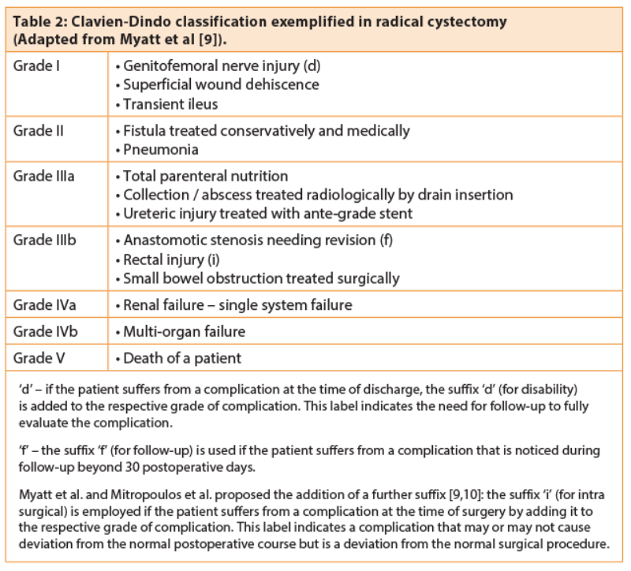

Attachment 2:
